1. 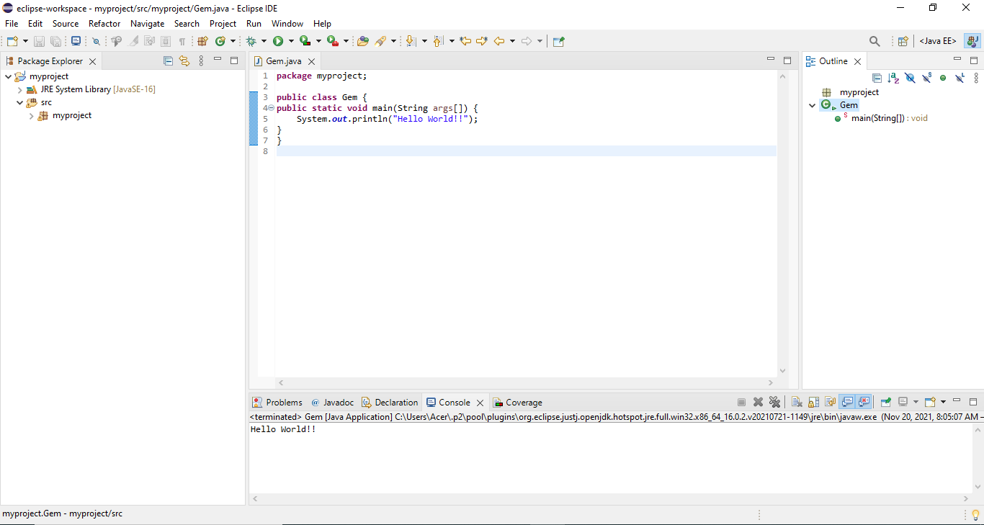Write a 'hello world" program in Java.

**Name: Jiban thing Roll No: 13 Non-Credit: Assignment**

1. 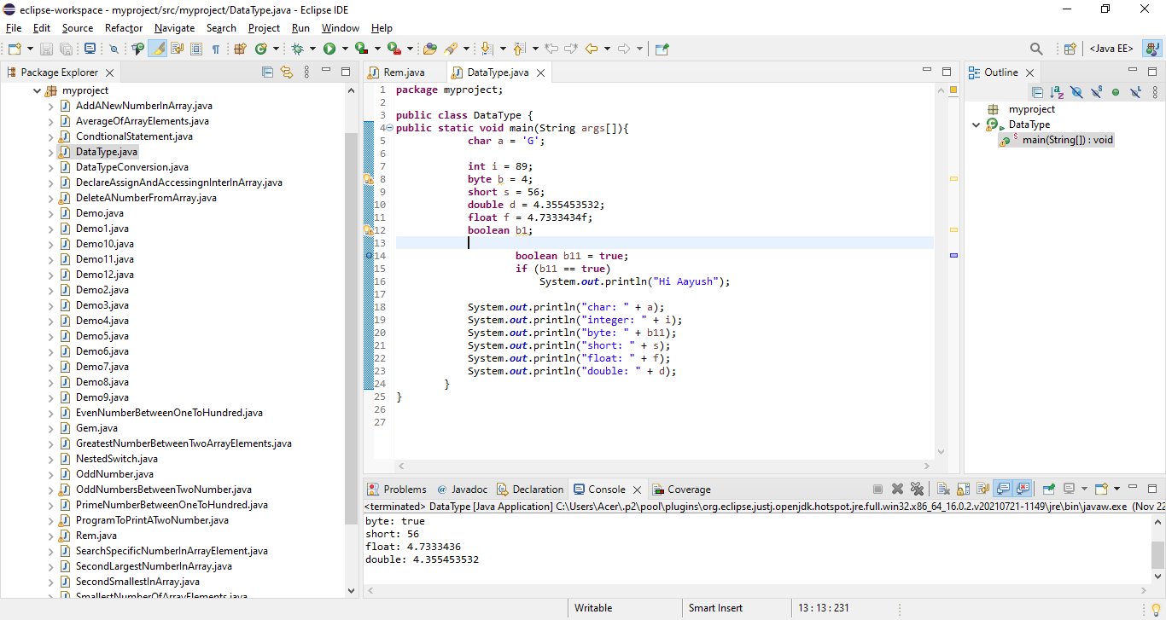Write a program which accept and print all basic data types of Java
2. 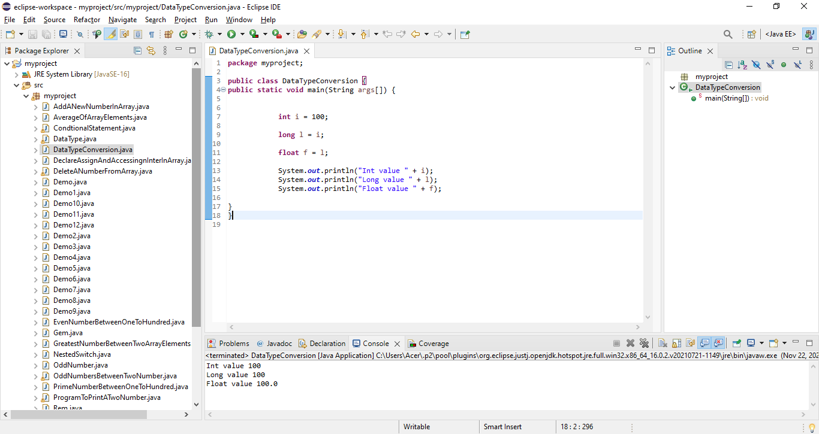Write a program to convert data types.
3. 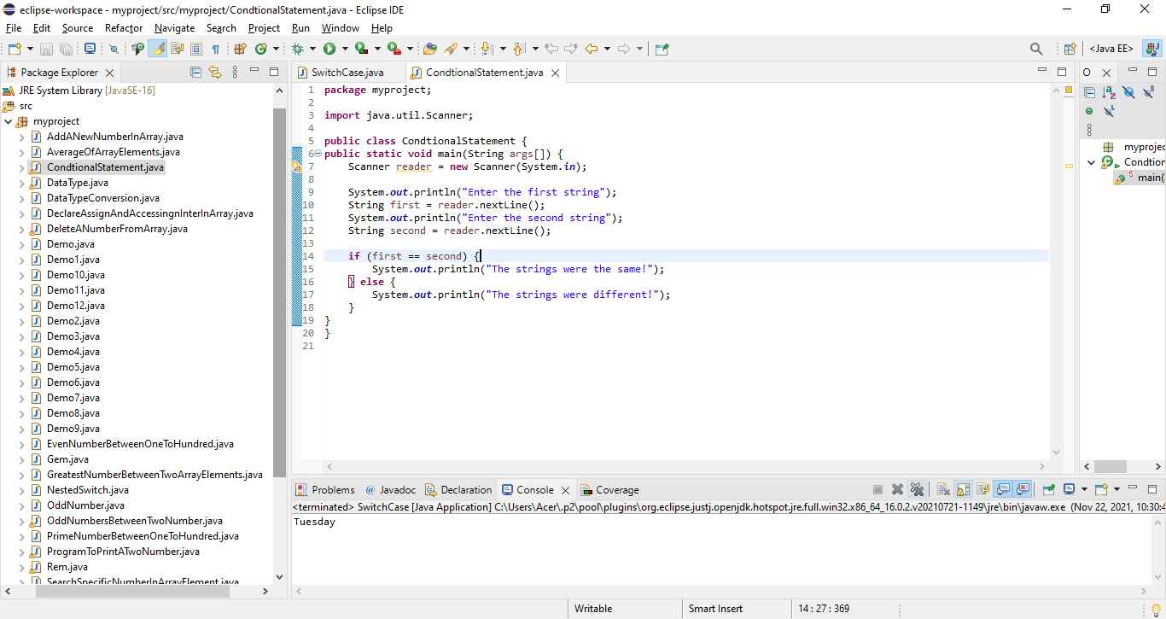Write a program which demonstrate the used if statement.
4. 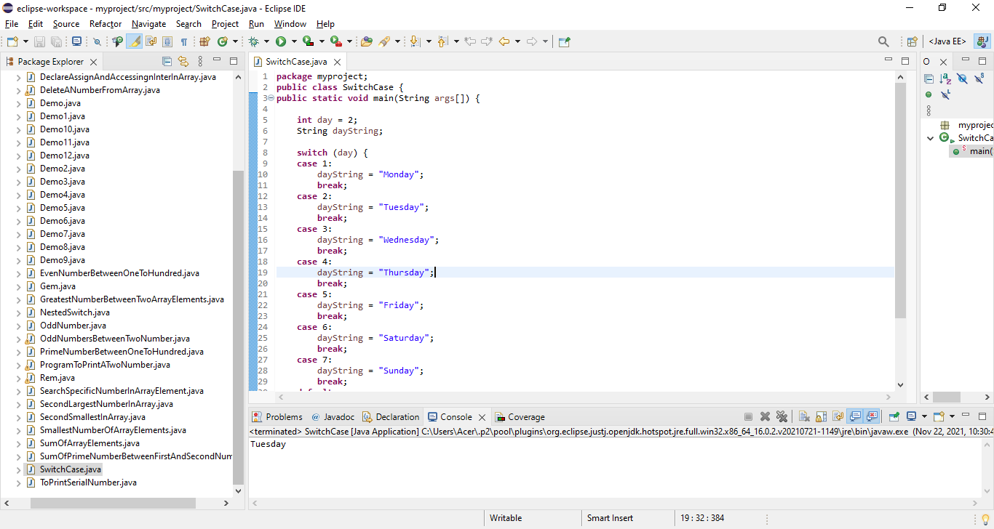Write a program which demonstrates the use switch statement.
5. 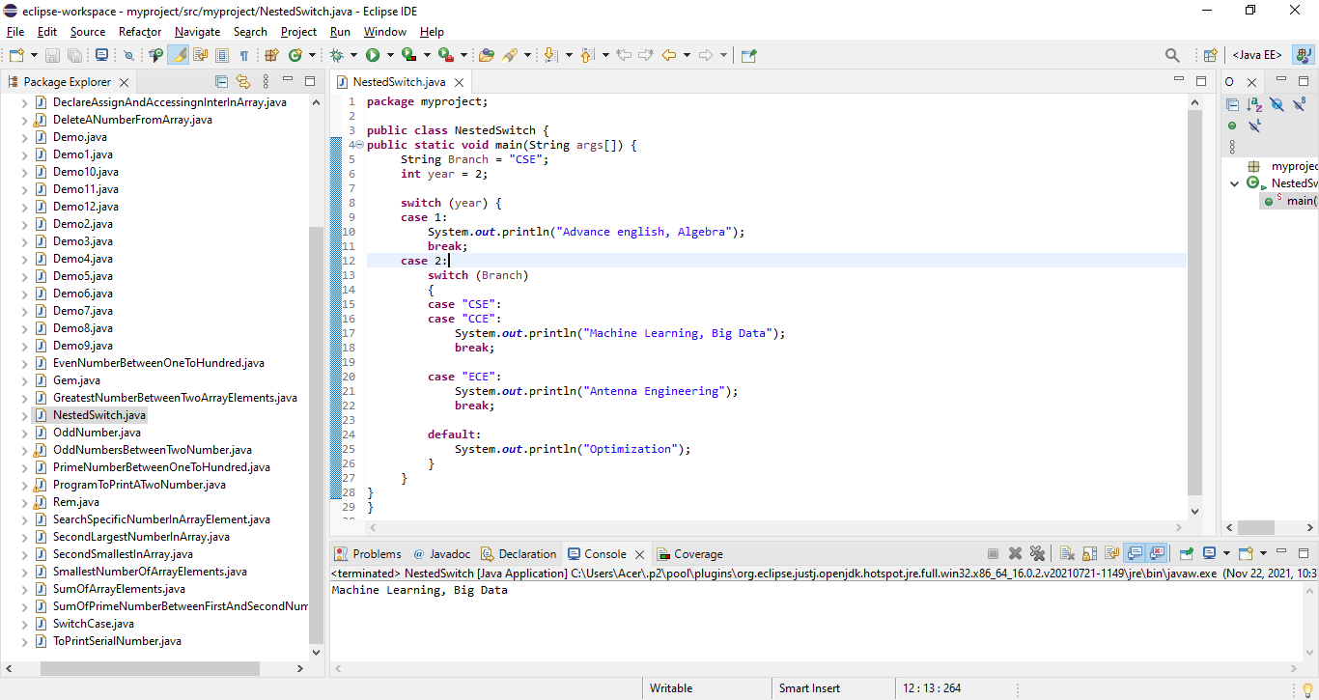Write a program which demonstrates the use nested switch statement.
6. 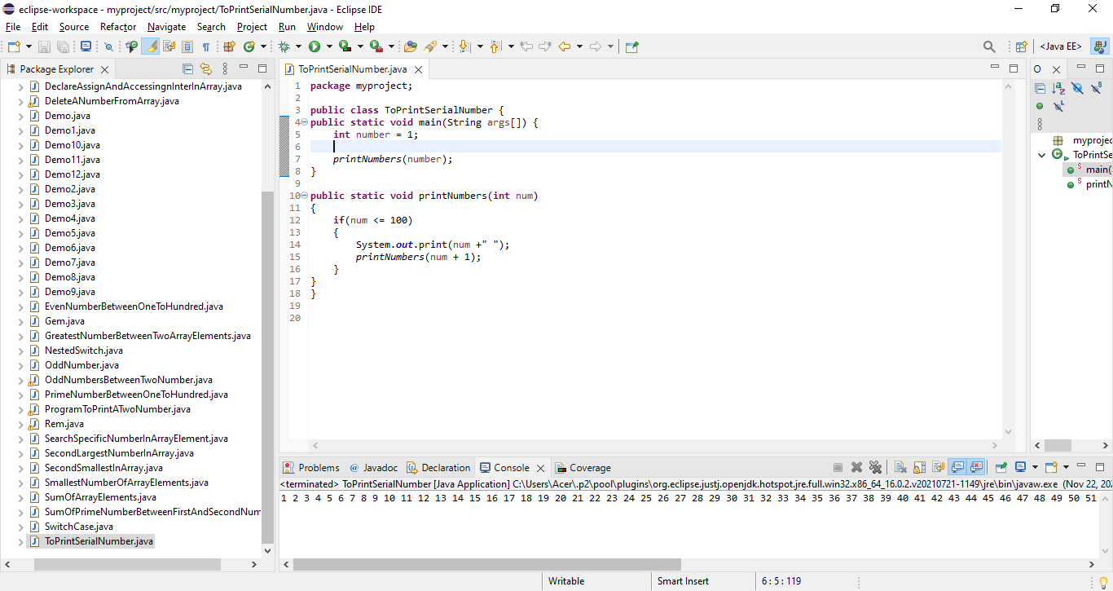Write a program to print 1 to 100.
7. 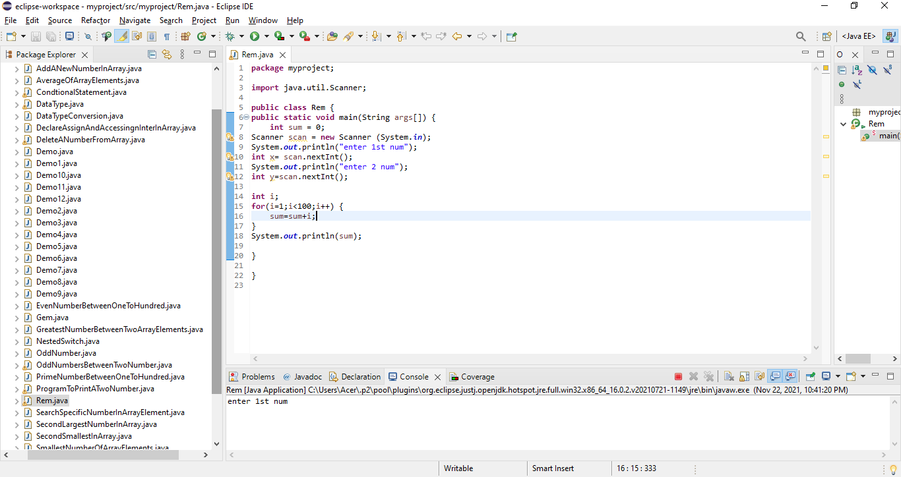Write a program to print n1 to n2.
8. 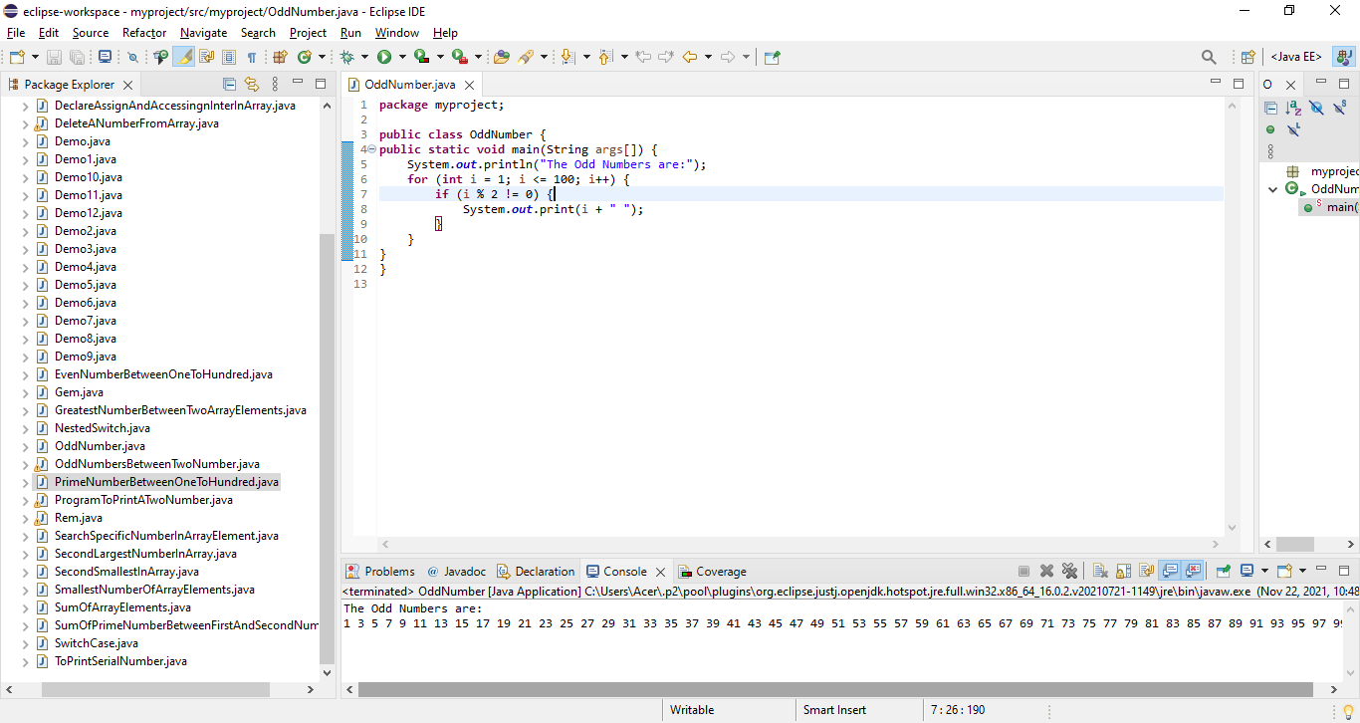Write a program to print odd numbers between 1 to 100.
9. 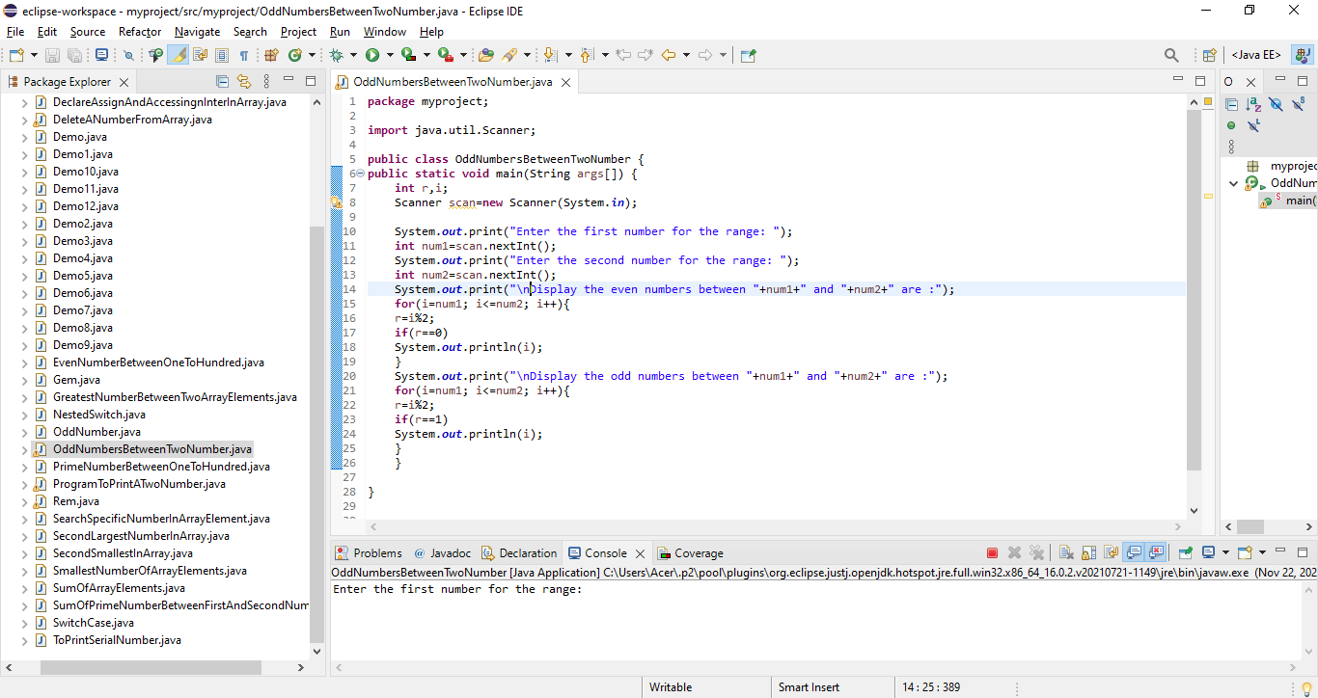Write a program to print odd numbers between n1 to n2.
10. 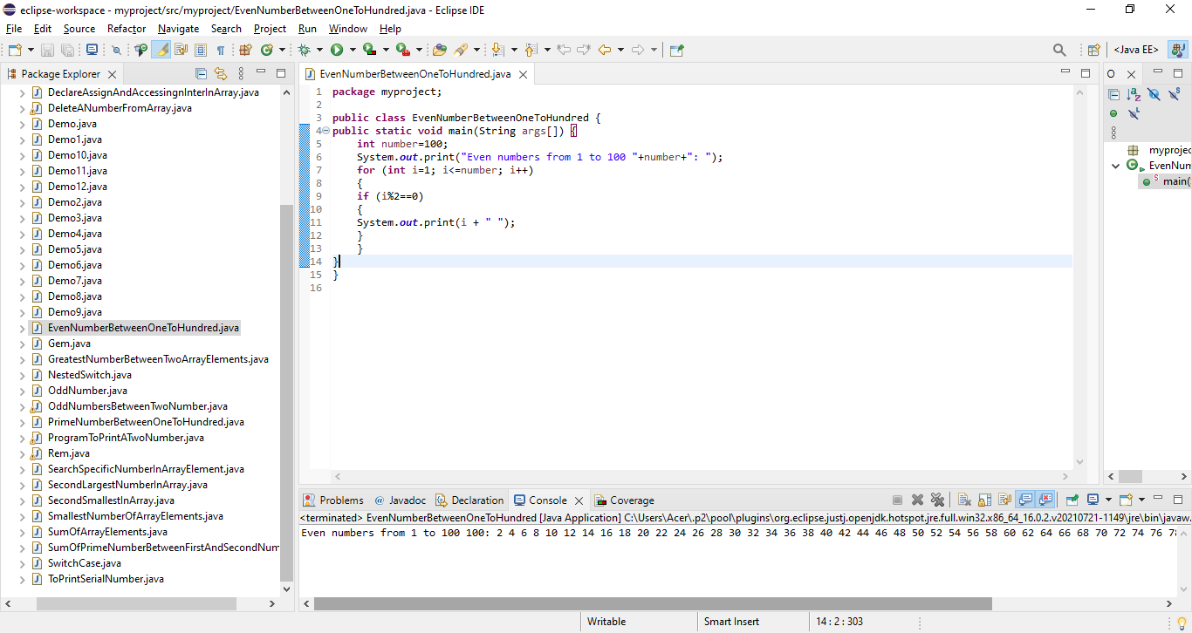Write a program to print even numbers between 1 to 100.
11. 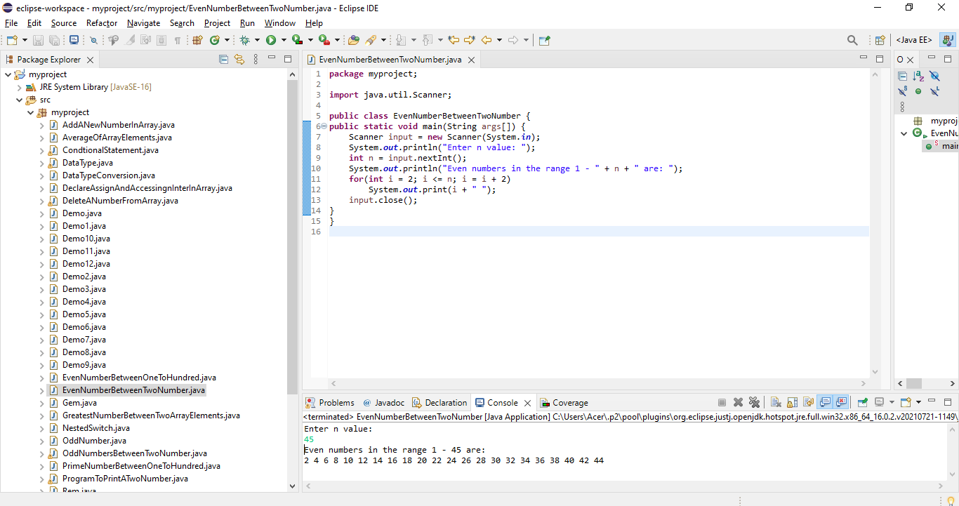Write a program to print even numbers between n1 to n2.
12. 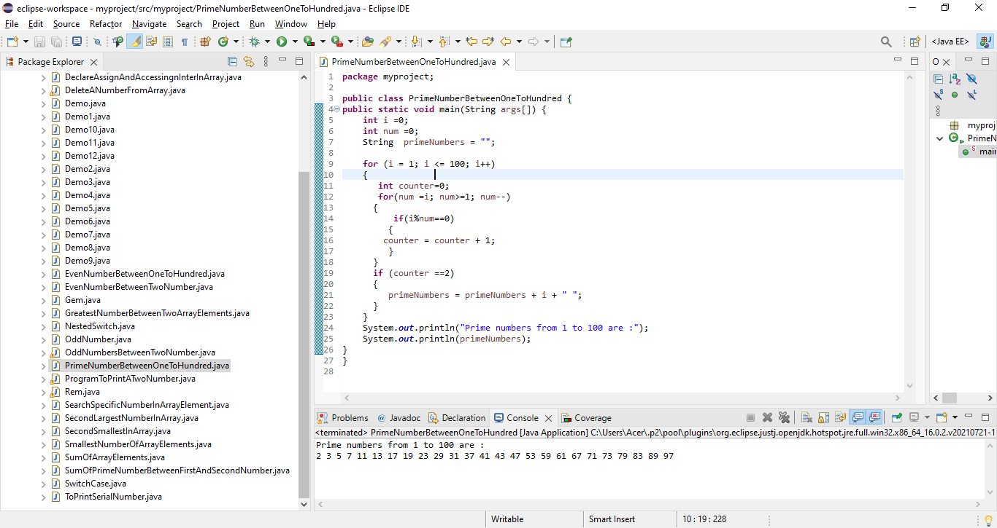Write a program to print prime numbers between 1 to 100.
13. 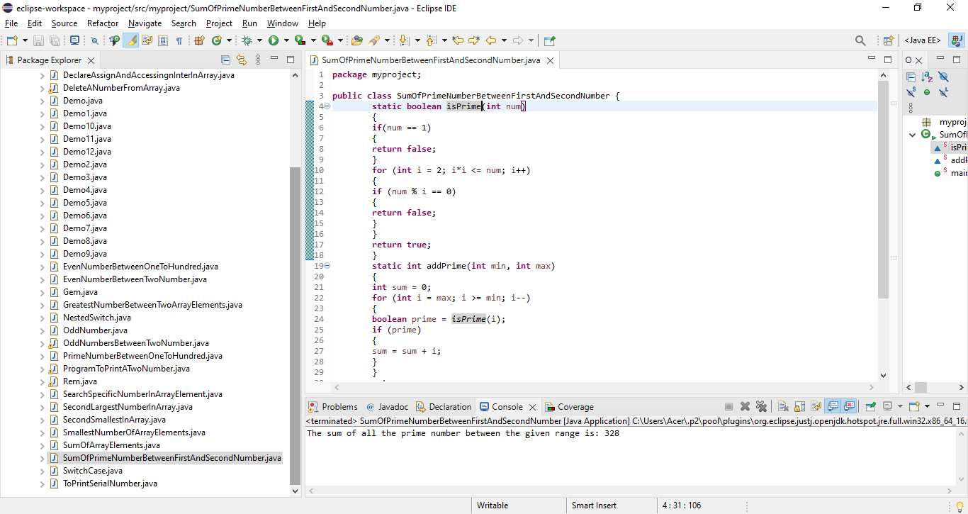Write a program to print prime numbers between n1 to n2.
14. Write a program to print sum of 1 to 100.
15. 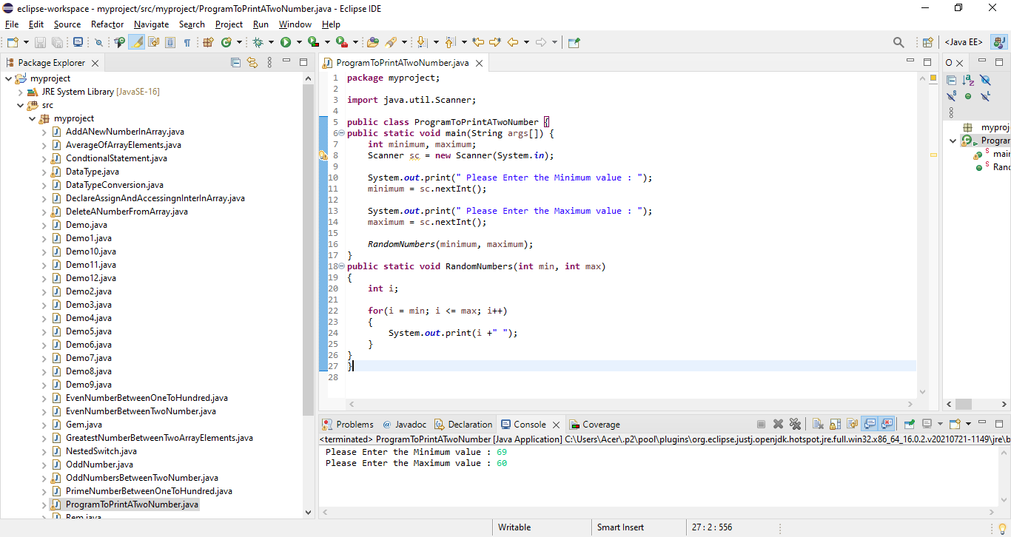Write a program to print sum of n1 to n2.

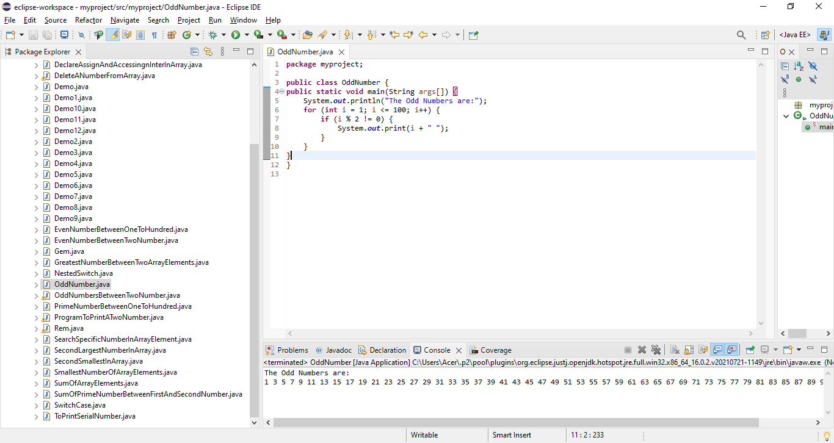17.Write a program to print sum of odd numbers between 1 to 100.

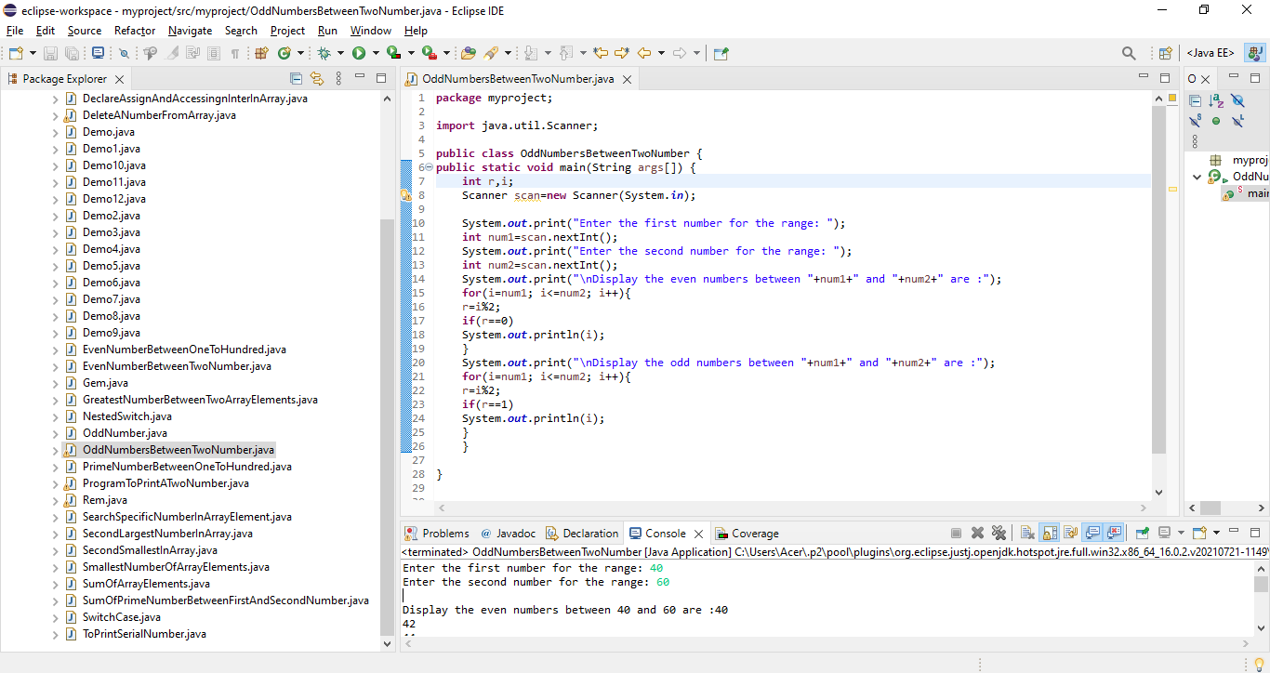18.Write a program to print sum of odd numbers between n1 to n2.

19. Write a program to print sum of even numbers between 1 to 100.

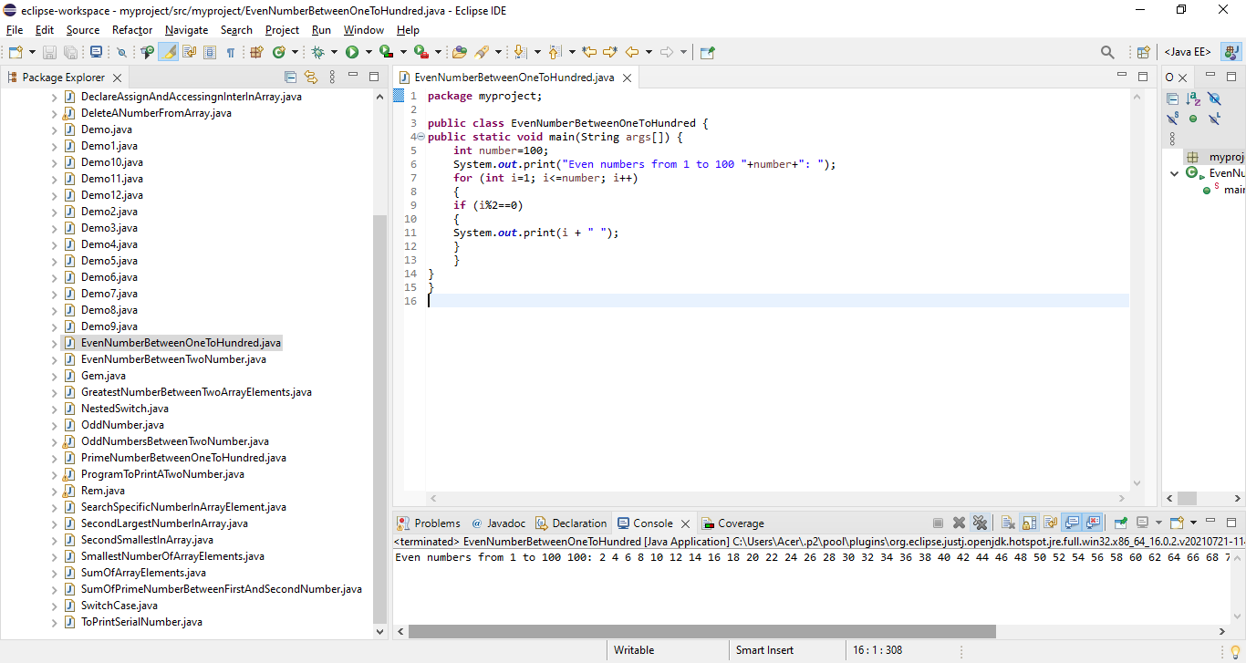

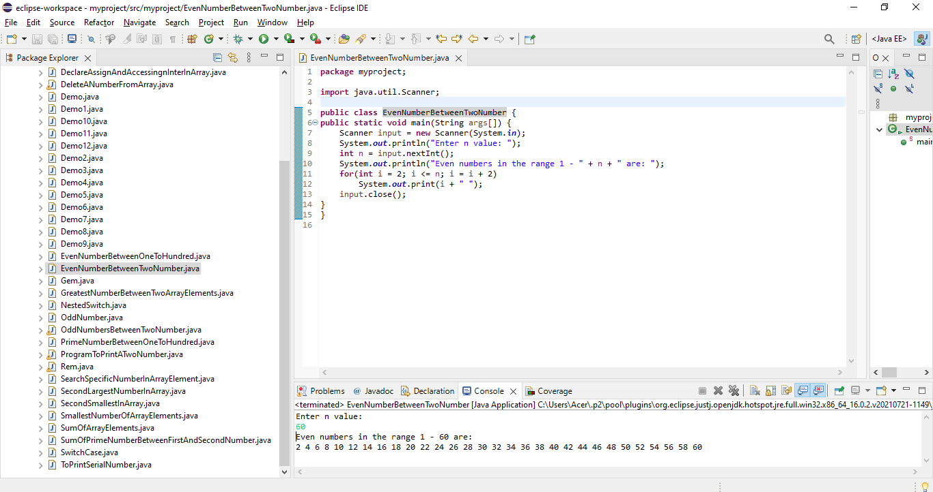20. Write a program to print sum of even numbers between n1 to n2.

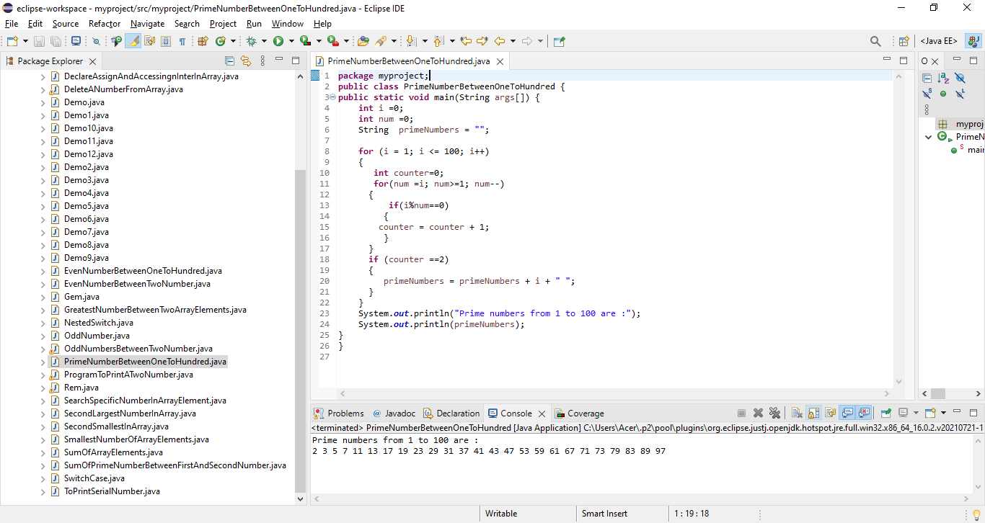21. Write a program to print sum of prime numbers between 1 to 100.

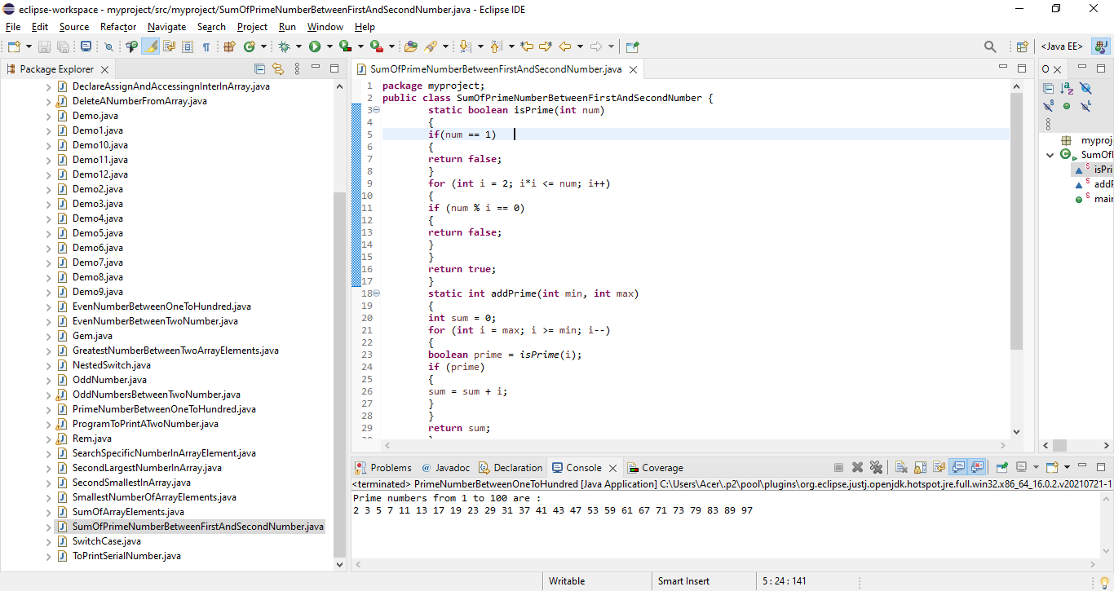22. Write a program to print sum of prime numbers between n1 to n2.

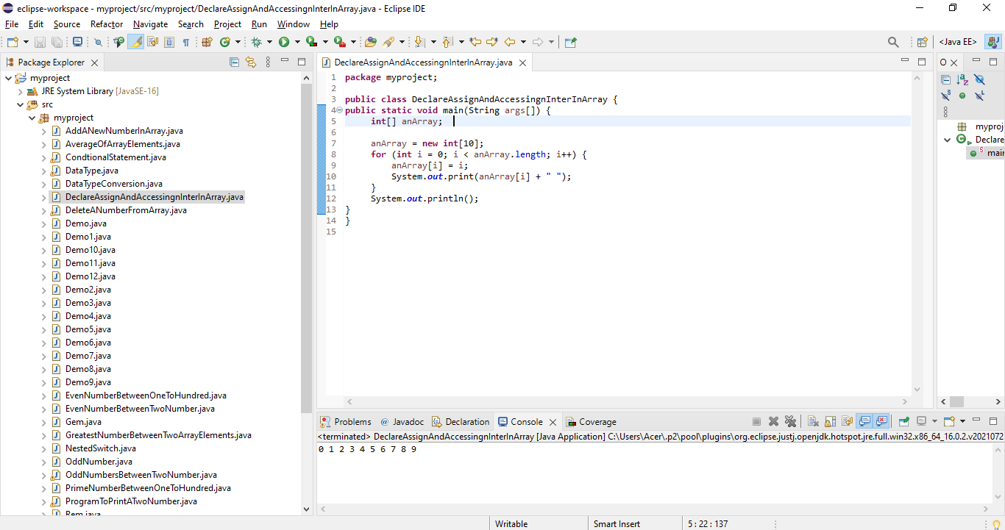23. Write a program to declare, assign and accessing integer array.

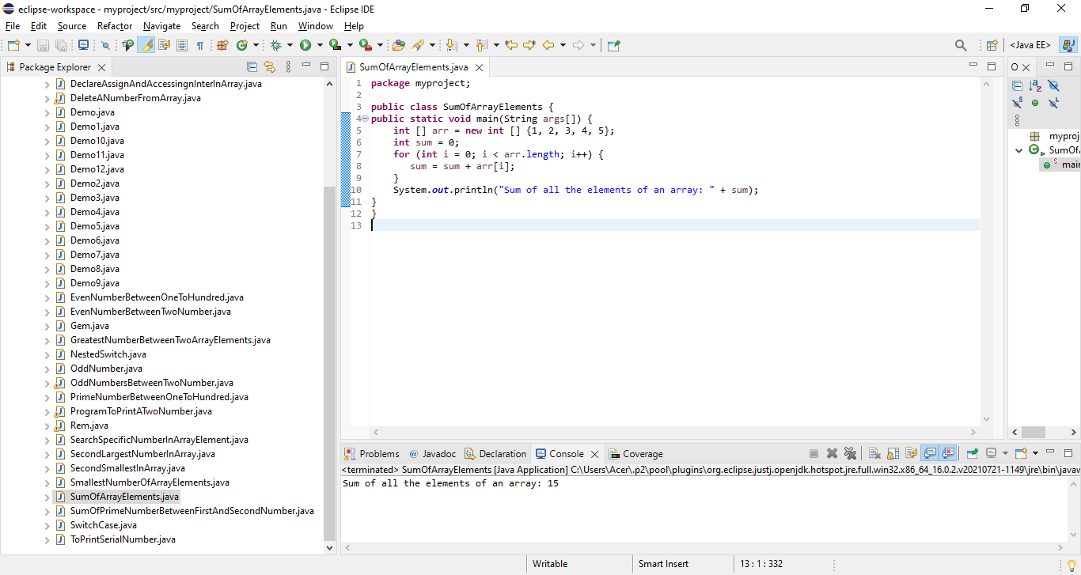24. Write a program to print the sum of array elements.

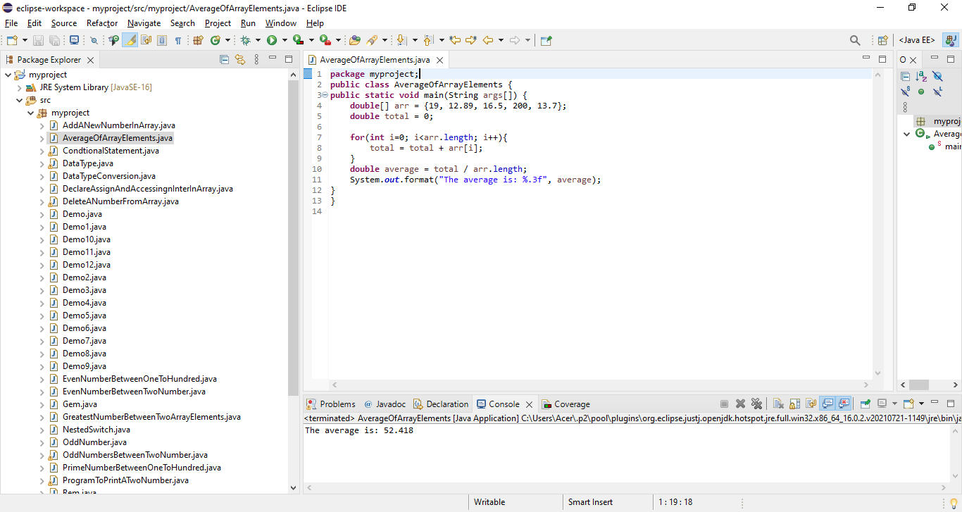25. Write a program to print the average of array elements.

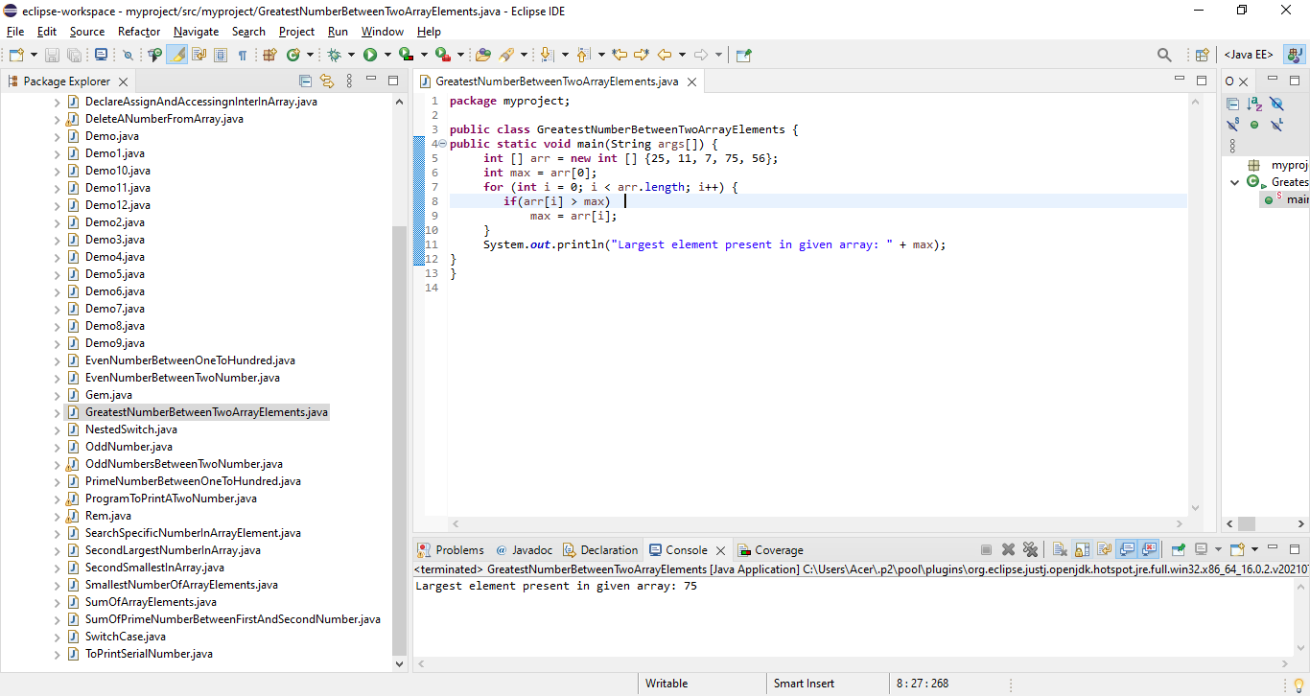26. Write a program to print greatest number of array elements.

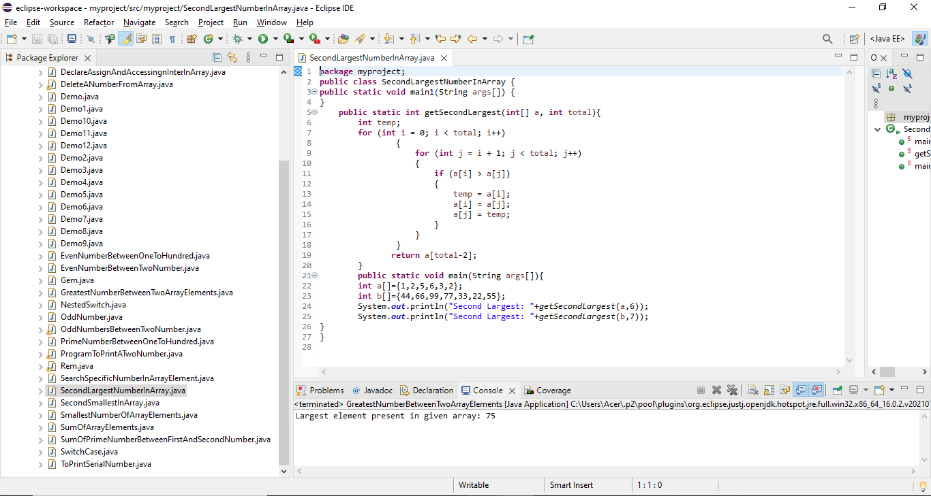27. Write a program to print second greatest number of array elements.

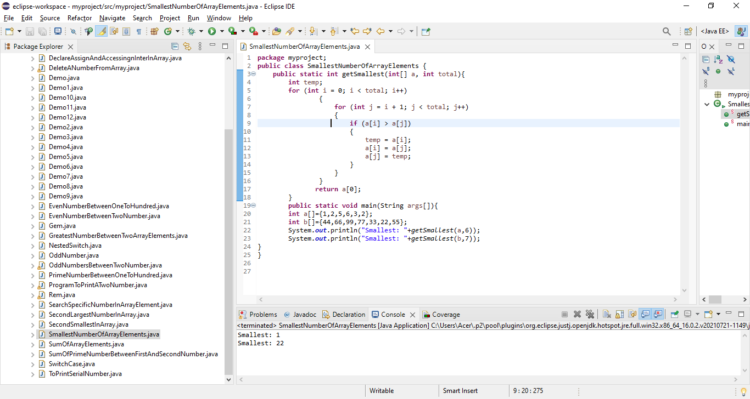28. Write a program to print smallest number of array elements.

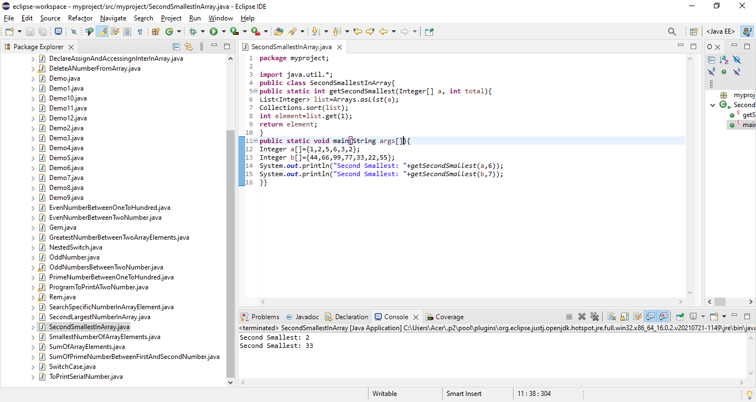29. Write a program to print second smallest number of array elements.

30. Write a program to search specific number within array elements and print the number of repetitions.

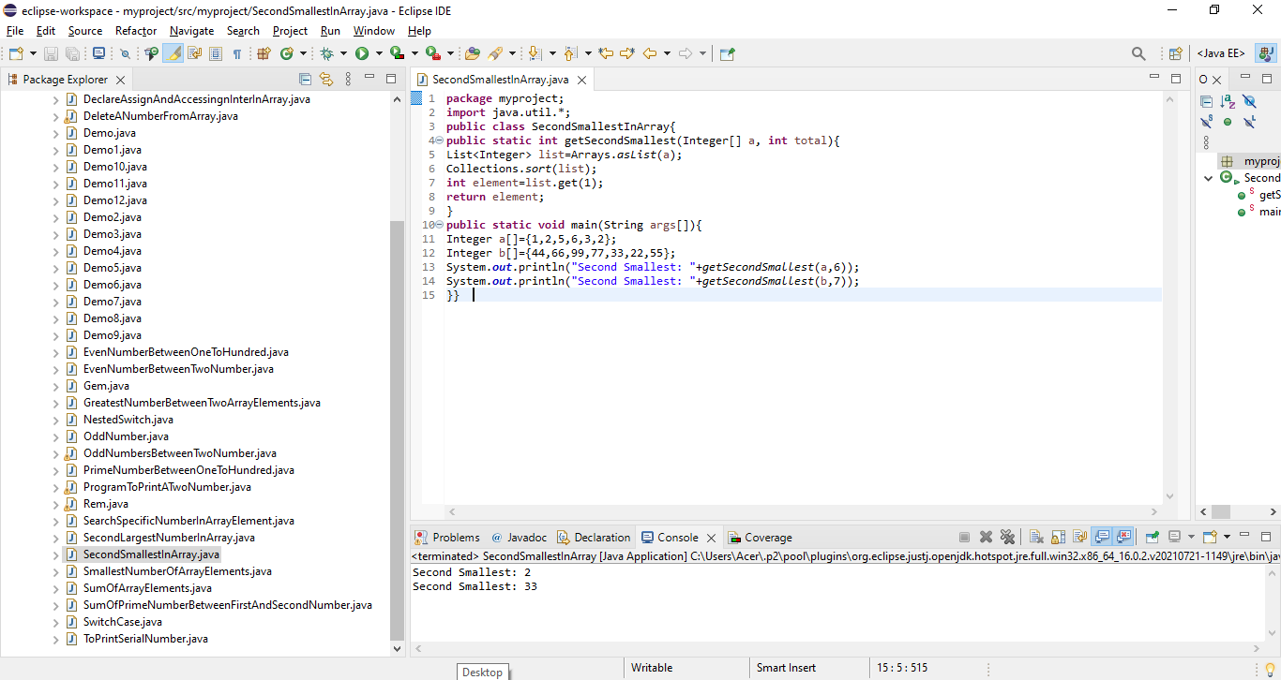

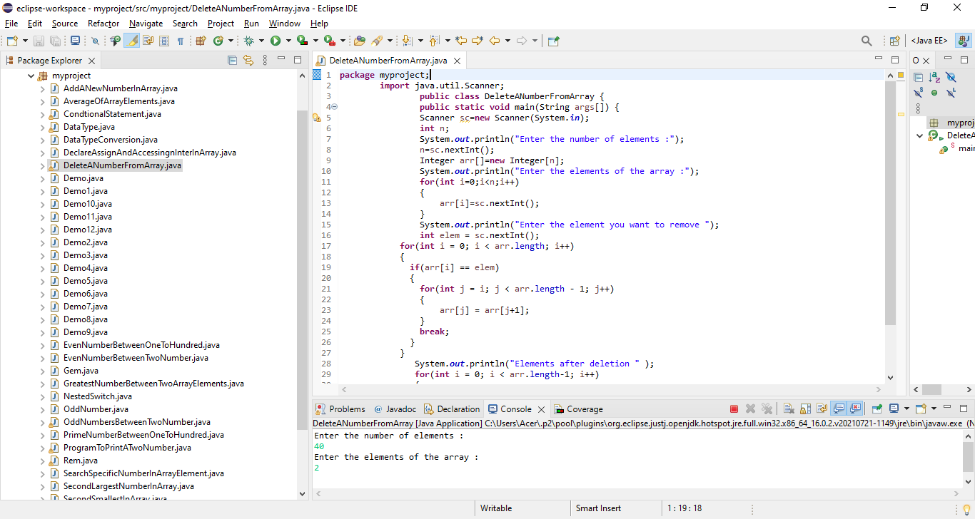31. Write a program to delete a number from array

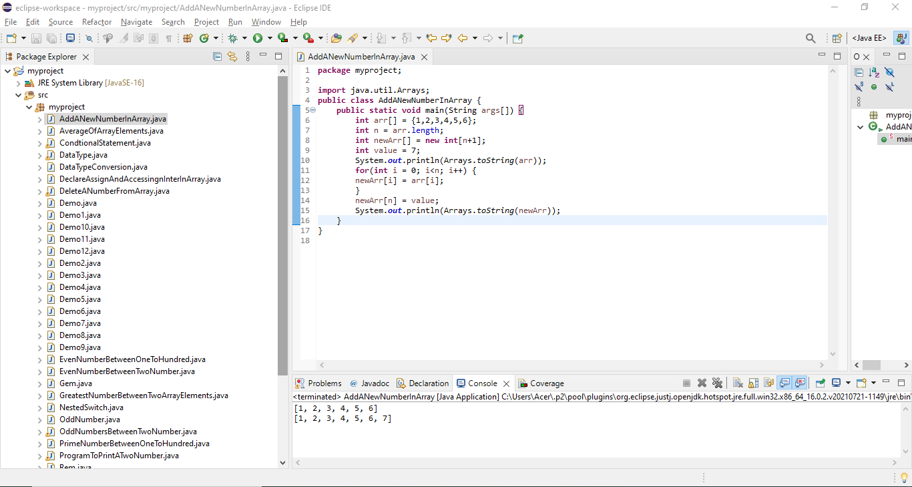32. Write a program to add new number in array.